NEWS RELEASE
Contact: Cara DelleChiaie
cara@fgiguidelines.org
FOR IMMEDIATE RELEASE
January 12, 2024

FGI Announces New Podcast: Between the Lines with FGI
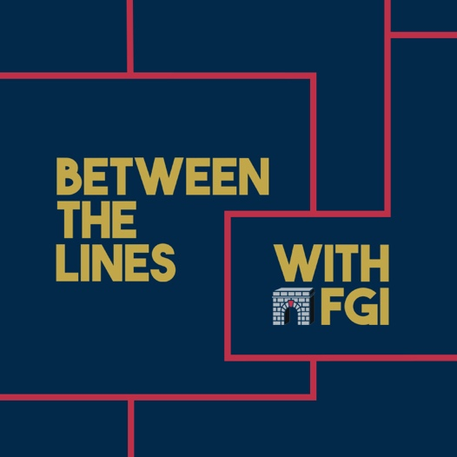
FLORENCE, MA. – Facility Guidelines Institute (FGI) proudly announces its new podcast Between the Lines with FGI with “Episode 1—The Genesis of the Guidelines: Doug Erickson” released today on all major podcast outlets. Between the Lines with FGI offers an informal exploration of the FGI Guidelines for Design and Construction documents and related health care design topics. Each 20- to 45-minute episode features interviews with industry experts, using a conversational approach to explore challenging questions and provide tools to facilitate compliance conversations.
Between the Lines with FGI is hosted by John Williams, FGI’s vice president of content and outreach and chair of the 2026 Health Guidelines Revision Committee, and Bridget McDougall, associate editor at FGI. They bring together knowledge and experience from their respective roles with FGI and delight listeners of all backgrounds with their engaging discussions.
“For years, we’ve heard from users of the Guidelines that they want more stories about the intent behind the minimum standards for health care design,” says Williams. “We hope this podcast provides both a place for education and a way for our audience to engage with FGI and ask us questions.”
Host John Williams
“Episode 1—The Genesis of the Guidelines: Doug Erickson” dives into the history of the Guidelines with an interview with Doug Erickson, former chief executive officer and founding board member of FGI. “Whether listeners are new to the Guidelines or have a copy within reach at all times, we wanted to start where it all began,” says McDougall. “And there is truly no better guest to have that discussion with than Doug Erickson.”
Host Bridget McDougall
Northstar Management Company, LLC, has been named as the first sponsor of Between the Lines with FGI. “Given that episodes two and three of the podcast will focus on functional programming, Northstar is the ideal sponsor,” says FGI CEO Heather Livingston. “As an owner’s representative and program management company, Northstar has a reputation for expertly guiding clients through the complex process of planning, design, and construction, including functional programming—a crucial but often overlooked tool to prioritize key environment of care considerations and drive the space program for a project. We gratefully acknowledge the support of CEO Ken Cates and Northstar Management Company.”
Season one of Between the Lines of FGI also covers best practices for developing a functional program and goes behind the scenes with an infection preventionist. New episodes will be released on the second and fourth Fridays of each month (with a brief break in the summer) on all major podcast outlets.
###

About the Facility Guidelines Institute
Founded in 1998, the Facility Guidelines Institute is a not-for-profit corporation founded to provide leadership and continuity to the Guidelines revision process. FGI functions as the coordinating entity for development of the Guidelines series of documents using a multidisciplinary, consensus-based process and for provision of ancillary services that encourage and improve their application and use.

About the FGI Guidelines for Design and Construction Documents
The FGI Guidelines for Design and Construction documents are updated every four years to keep pace with new concepts, capabilities, and technologies in the delivery of health care. The Guidelines documents are used by states, through adoption by reference, to regulate health and residential care facility design and construction. FGI invests revenue derived from sales of the Guidelines to fund research and the activities of the next revision cycle. The Guidelines documents are protected by copyright and authorized licenses and paperbacks are available exclusively at https://shop.fgiguidelines.org.

